Experiment No. 01

1.Write a program to display personal biodata.
print("Enter your details:")

name = input("Name: ")
age = input("Age: ")
gender = input("Gender: ")
address = input("Address: ")
phone = input("Phone No.: ")
email = input("Email: ")

print("\n----- PERSONAL BIODATA -----")
print("Name :", name)
print("Age :", age)
print("Gender :", gender)
print("Address :", address)
print("Phone No. :", phone)
print("Email :", email)
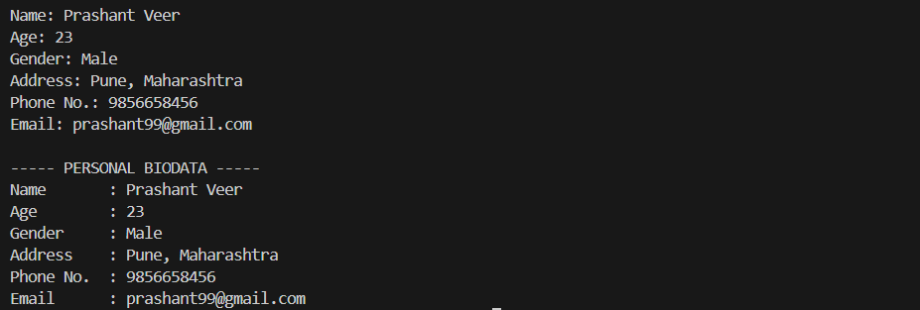

2. Write a program to perform arithmetic operations on two numbers.
num1 = float(input("Enter first number: "))
num2 = float(input("Enter second number: "))

print("\nChoose operation:")
print("1. Addition")
print("2. Subtraction")
print("3. Multiplication")
print("4. Division")

choice = int(input("Enter choice (1-4): "))

if choice == 1:
print("Result:", num1 + num2)
elif choice == 2:
print("Result:", num1 - num2)
elif choice == 3:
print("Result:", num1 * num2)
elif choice == 4:
if num2 != 0:
print("Result:", num1 / num2)
else:
print("Cannot divide by zero")
else:
print("Invalid choice")
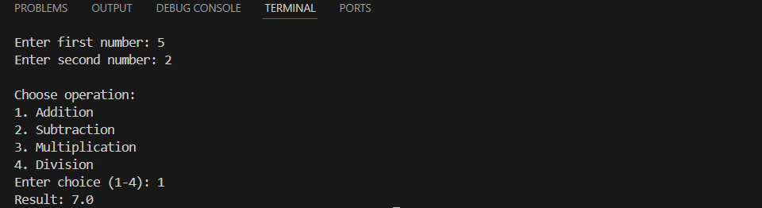
3. Write a program to swap two numbers (with and without temporary variable).
# Input
num1 = int(input("Enter first number: "))
num2 = int(input("Enter second number: "))

print("\nOriginal values:")
print("num1 =", num1)
print("num2 =", num2)

# --- Using temporary variable ---
a = num1
b = num2

temp = a
a = b
b = temp

print("\nAfter swapping (using temporary variable):")
print("num1 =", a)
print("num2 =", b)

# --- Without temporary variable (Python method) ---
c = num1
d = num2

c, d = d, c

print("\nAfter swapping (without temporary variable):")
print("num1 =", c)
print("num2 =", d)
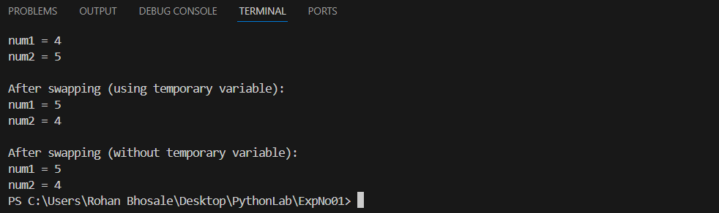

4. Write a program to find simple interest.
p = float(input("Enter principal: "))
r = float(input("Enter rate: "))
t = float(input("Enter time: "))
si = (p * r * t) / 100
print("Simple Interest =", si)
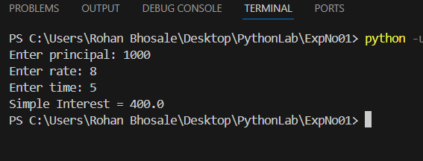

5. Write a program to convert temperature from Celsius to Fahrenheit.
c = float(input("Enter temperature in Celsius: "))
f = (c * 9/5) + 32
print("Temperature in Fahrenheit =", f)
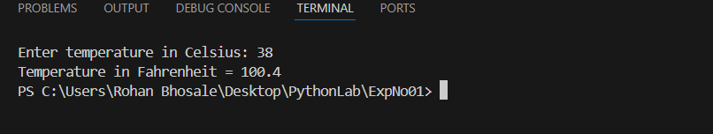

6. Write a program to calculate area and perimeter of a rectangle.
length = float(input("Enter length: "))
breadth = float(input("Enter breadth: "))
area = length * breadth
perimeter = 2 * (length + breadth)
print("Area =", area)
print("Perimeter =", perimeter)
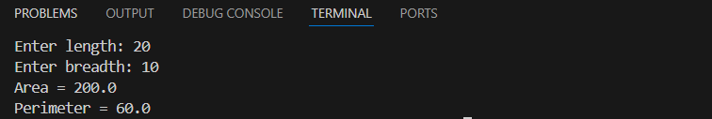

7. Write a program to check whether a number is positive, negative or zero.
num = float(input("Enter a number: "))
if num > 0:
print("Positive number")
elif num < 0:
print("Negative number")
else:
print("Zero")

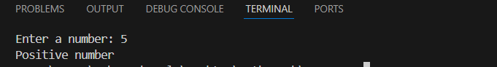

8. Write a program to convert days into years, weeks and days.
days = int(input("Enter number of days: "))
years = days // 365
weeks = (days % 365) // 7
remaining_days = (days % 365) % 7
print("Years =", years)
print("Weeks =", weeks)
print("Days =", remaining_days)
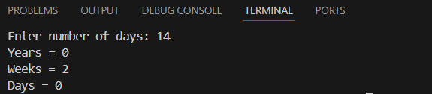

9. Write a program to calculate square and cube of a number.
num = int(input("Enter a number: "))
square = num * num
cube = num * num * num
print("Square =", square)
print("Cube =", cube)
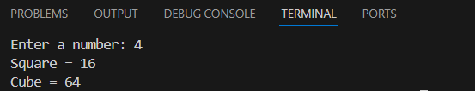

10. Write a program to demonstrate use of relational and logical operators.
a = int(input("Enter first number: "))
b = int(input("Enter second number: "))
print("a > b :", a > b)
print("a < b :", a < b)
print("a == b :", a == b)
print("a != b :", a != b)
print("a >= b :", a >= b)
print("a <= b :", a <= b)
